JUAN DELGADO
Data Science and Analytics Portfolio
[ Rochester, New York ] • [ delgado.juan329@gmail.com ] • [ LinkedIn ] • [ GitHub ]

I. Executive Summary
Sales professional with 8 years in the optical industry, partnering with independent optometry offices to drive patient retention, profitability, and growth. With completing a Master of Science (M.S.) in Applied Data Science (AI Focus) at Syracuse University, I combine frontline commercial experience with machine learning to bridge the gap between sales intuition and analytic precision. The projects that follow show how applied data science can turn insights into decisions a commercial team will actually act on.

Professional Summary
Currently managing a $52M portfolio at Kering Eyewear with 30% channel growth over three years and a consistent record of growth. Combines frontline commercial expertise with hands-on technical skills — Python, VBA, advanced Excel, SAP Business Objects and Salesforce — while completing an M.S. in Applied Data Science (AI Focus) at Syracuse University. Multilingual in Spanish, French, and German, with a track record of turning analysis into decisions that sales teams will execute to grow the business.

Key Accomplishments
- Grew $52M strategic partnerships portfolio 30% over three years at Kering Eyewear, managing 20+ key accounts
- Selected to manage two internal programs at Kering Eyewear: Field Sales Synergy Lead and Field Sales Internship
- Built Python and VBA automation tools for sales reporting and lead generation, reducing manual workflows for both self and team
- Exceeded new customer acquisition goal by 140% (28 of 20) in first year as Member Engagement Manager at CECOP USA
- Delivered 99-105% of quota across four consecutive sales periods at CooperVision (FY18, FY19, Q4 FY20, FY21)
- Recognized 4x on Commercial Highlights by President of Sales and named Sales Advisor at CooperVision (Oct 2019 – Dec 2021)

II. Education
Master of Science in Applied Data Science (AI Focus) May 2026
Syracuse University – Syracuse, NY 13244

Bachelor of the Arts in International Business May 2016
Bachelor of the Arts in French May 2016
SUNY College at Brockport - Brockport, NY 14420

III. Skills

Languages

English (Native), Spanish (Native), German (Proficient), French (Proficient)

Microsoft Office

Excel, PowerPoint, Word, Outlook

Programming Languages
Python, R, VBA, SQL, HTML

Data Analysis & Visualization
Pandas, NumPy, Matplotlib, ggplot2, Data Cleaning, Data Wrangling, Machine Learning integration

Machine Learning
Supervised/Unsupervised Learning, Regression, Classification, Clustering, TensorFlow, Keras, PyTorch.

Other Relevant Skills
Public speaking, statistical modeling, experimental design, communication, problem-solving, teamwork.

IV. Projects

Project 1: Analyzing US Geographic Mobility and Median Income to Find Counties and States with Top Sales Growth Potential

IST 652 – Scripting for Data Analysis

Problem Statement
Businesses seeking to expand into new markets often rely on broad demographic assumptions or raw income data, which tend to favor large metropolitan areas and overlook emerging high-potential markets. This approach leads to inefficient territory planning and missed growth opportunities in smaller, rapidly developing regions.
This project addresses that gap by leveraging U.S. Census data on geographic mobility and median income to identify counties and states where rising income levels among newly arrived residents, combined with measurable population inflow, signal untapped sales growth potential. The goal is to produce targeted, data-driven recommendations that enable more precise and effective business development decisions.

Data Sources
This project utilized two primary data sources from the U.S. Census Bureau, selected for the reliability, geographic granularity, and relevance to measuring both income and population movement at the country level. Below are the datasets that were used to calculate and normalize migration inflow rates at the county level, validating that income trends were supported by actual residential migration patterns.
1. American Community Survey (ACS) — 1-Year Estimates
- Provider: U.S. Census Bureau
- Years Used: 2022 and 2023
- Access Method: Census Bureau API and downloadable tables

2. Current Population Survey (CPS) — Geographic Mobility Supplement
- Provider: U.S. Census Bureau
- Years Used: 2022 and 2023
- Access Method: Downloadable microdata files

Techniques & Tools
This project demonstrates a full data analysis pipeline, from raw data acquisition thtough final visualization, using industry-standard Python libraries and analytical methods. The following summarizes the core techniques and tools applied at each stage of the workflow.
Tool / Library | Purpose
Python | Primary programming language for all scripting and analysis
Pandas | Data cleaning, transformation, merging, and aggregation
NumPy | Numerical computations and array operations
GeoPandas | Geospatial data handling and county-level spatial joins
Contextily | Adding basemap tiles to geographic visualizations
Matplotlib | Chart creation and plot customization
U.S. Census API | Programmatic data retrieval from Census Bureau endpoints
Google Colaboratory | Interactive development, documentation, and result presentation

Results & Impact
The analysis produced clear, data-driven findings that moved beyond broad market assumptions to identify specific counties and regions with the strongest sales growth potential. Results were evaluated across two primary dimensions, income growth among newly arrived residents and population inflow rates, to highlight the most compelling business opportunities.

These counties showed the largest percentage increase in median income among newly arrived residents compared to the existing county baseline. They also highlight smaller, non-metropolitan counties that traditional raw income analysis would have overlooked entirely.
Rank | County | State | Income Increase
1 | Geauga County | OH | 340%
2 | Saline County | AR | 186%
3 | Walton County | GA | 177%

Visualizations
One core objective of this project was translating complex, multi-variable analysis into clear visual outputs that could communicate findings to both technical and non-technical audiences. All visualizations were produced using GeoPandas and Contextily in Python, with county-level census data joined to U.S. shapefile boundary files to enable geographic mapping.
The maps below show the top counties in Texas with potential growth opportunity.
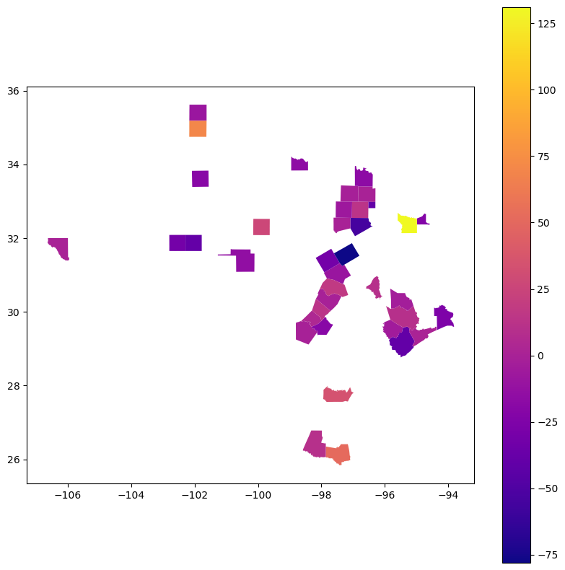
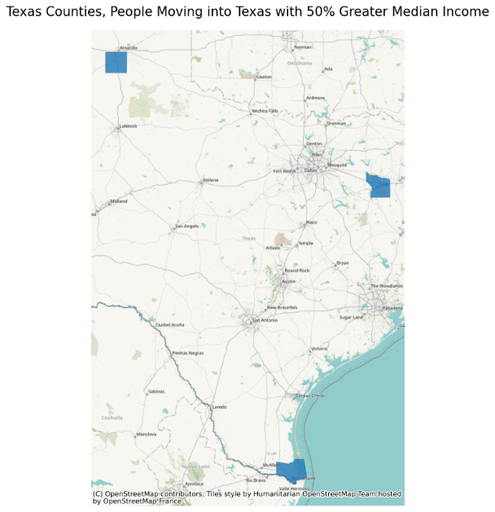

Learnings & Next Steps
This project produced both technical and strategic insights that extended well beyond the immediate findings. By building a full data pipeline from raw census data to geographic visualizations and business recommendations, this project can be replicated in the future with updated census data. Furthermore, it would be interesting to analyze the changes of the top counties over time, as well as further research as to reasons why these dollars are flowing into specific counties for further business development strategy.

Link to Code
https://github.com/juan-delgado329/us-census-data-analysis-for-geographic-sales-leads

Project 2: Association Rule Mining B2B Eyewear Transactions

IST 718 – Big Data Analytics

Problem Statement
In large-scale B2B retail environments, sales teams and ordering platforms often lack the data-driven insight needed to identify which products are frequently purchased together. Without visibility into cross-product purchasing patterns, businesses miss opportunities to increase average order size, optimize product recommendations, and reinforce effective selling strategies.
This project addresses that gap by applying association rule mining to over 50,000 rows of B2B eyewear transaction data, using the FP-Growth algorithm in PySpark to uncover meaningful purchasing patterns across thousands of customer orders. The goal was to translate those patterns into actionable recommendations that can guide bundling strategies, inform field sales teams, and support product recommendation features within B2B ordering platforms.

Data Sources
This project utilized a single proprietary dataset drawn from real-world B2B eyewear transaction records. The dataset represented a large-scale, production-level source of sales data, making it well suited for applying big data analytics techniques and distributed computing tools.

Primary Dataset — B2B Eyewear Transaction Data
- Source: Internal B2B eyewear sales transaction records
- Volume: Approximately 10,000 transactions and over 50,000 rows of data
- Granularity: SKU-level transaction data capturing individual product purchases within each customer order

Key Characteristics
Attribute | Detail
Transaction Count | ~10,000 orders
Row Count | 50,000+ records
Product Coverage | 50+ unique SKUs
Data Type | B2B wholesale purchase records
Notable Feature | Included Key Performing Styles (KPS) designation by product

Techniques & Tools
This project applied big data analytics techniques to analyze large-scale B2B transaction data. The following summarizes the core methods and technologies used at each stage of the workflow, from data preparation through model tuning and business interpretation.
Tool / Library | Purpose
Python | Primary programming language for all scripting and analysis
PySpark | Distributed computing framework for processing large-scale transaction data
FP-Growth (MLlib) | Association rule mining algorithm for identifying frequent item sets
Pandas | Supporting data manipulation and preprocessing tasks
Google Colaboratory | Interactive development, documentation, and result presentation

Results & Impact
The analysis successfully identified meaningful purchasing patterns across thousands of B2B eyewear transactions, producing association rules and frequent item sets that translate directly into actionable sales and product recommendation strategies. Results were evaluated across three iterative dataset configurations, with each iteration revealing progressively deeper insights into cross-product purchasing behavior.
The FP-Growth algorithm identified frequent item sets appearing consistently across a significant number of transactions, confirming that the purchasing patterns discovered were repeatable behaviors rather than isolated occurrences.
Metric | Result
Transaction Range of Item Sets | 134 to 497 transactions
Total Transactions Analyzed | ~10,000
Total Rows Processed | 50,000+
Top 30 Item Sets Containing KPS Products | 23 out of 30

The presence of Key Performing Styles (KPS) in 23 of the top 30 frequent item sets was a particularly significant finding. Although KPS products represented only about one-fourth of the total SKUs, their dominance in the results validated that the existing sales strategy around these products is working, and provided data driven evidence to support continued investment on KPS-focused selling initiatives.

Learnings & Next Steps
This project demonstrated that large scale transaction data contains rich, actionable intelligence that can directly improve sales performance, inform product strategy, and strengthen customer relationships. Analyzing future data sets would allow us to evaluate Key Performing Style initiatives with the goal of implementing a recommendation system in our online purchasing platform.

Link to Code
https://github.com/juan-delgado329/association-rule-mining-eyewear-transactions

Project 3: Convolutional Neural Networks using iPhone Images for Eyewear Classification

IST 691 – Deep Learning in Practice

Problem Statement
Sales teams operating in field environments often struggle to quickly and accurately identify eyewear products, particularly when working across large catalogs of visually similar styles and brands. Without a reliable, automated way to classify products, teams must rely on manual lookups or prior product knowledge, creating inefficiencies that slow down the sales process and increase the risk of misidentification.
This project addresses that gap by building and evaluating convolutional neural network (CNN) models capable of classifying eyewear products directly from iPhone images captured in realistic uncontrolled sales environments. The goal is to determine whether deep learning techniques, including transfer learning and hierarchical classification, can achieve strong classification accuracy. With the goal to support practical business applications such as automatic product identification, inventory tracking, and mobile based recommendation tools that can help sales teams operate more efficiently and drive higher value customer interactions.

Data Sources
This project utilized a proprietary dataset of eyewear product images captured specifically for this analysis. Unlike many deep learning projects that rely on large publicly available image datasets, this project was designed to reflect the realities of a field sales environment, where images are taken under imperfect, real-world conditions.
Primary Dataset — iPhone Eyewear Product Images
- Source: Original images captured using an iPhone camera
- Subject Matter: Eyewear products across multiple brands, styles, and product types
- Access Method: Directly captured and compiled for this project
- Environment: Realistic, uncontrolled sales conditions rather than professionally lit or staged photography

Key Characteristics
Attribute | Detail
Image Source | iPhone camera captures
Classification Levels | Fine level (individual style), product type, and brand
Environment | Uncontrolled, real-world sales conditions
Dataset Size | Limited dataset typical of a real-world business setting
Product Coverage | Multiple eyewear brands and styles across several product categories

Techniques & Tools
This project applied advanced deep learning techniques to evaluate multiple convolutional neural network architectures for eyewear product classification. The following summarizes the core techniques and tools used throughout the modeling, evaluation, and comparison process.
Tool / Library | Purpose
Python | Primary programming language for all modeling and analysis
TensorFlow / Keras | Deep learning framework for building, training, and evaluating CNN models
MobileNetV2 | Lightweight pretrained model used for transfer learning experiments
VGG16 | Pretrained model used for hierarchical CNN transfer learning
VGG19 | Deeper pretrained model evaluated as a comparison to VGG16
NumPy | Numerical computations and array operations
Matplotlib | Visualization of model training history, accuracy, and loss curves
Google Colaboratory | Interactive development, documentation, and result presentation

Results & Impact
The analysis successfully evaluated multiple convolutional neural network architectures for eyewear product classification, progressing from a poorly performing baseline model to a highly accurate transfer learning solution capable of supporting real-world business applications. Results were measured consistently across accuracy and loss metrics, with each modeling iteration building on the lessons of the previous one to produce progressively stronger outcomes.

Baseline CNN — Trained from Scratch
The baseline model established the performance floor for the project and confirmed the limitations of training deep learning models without sufficient data. These results were not a failure but an important data point, confirming that the transfer learning approach was necessary given the dataset size and constraints typical of a real business environment.

Metric | Result
Training Accuracy | 19.4%
Validation Accuracy | 14.4%
Interpretation | Model was essentially guessing across all product classes

Transfer Learning — MobileNetV2
Applying transfer learning with MobileNetV2 produced a dramatic improvement in classification performance. This result demonstrated that strong classification performance is achievable even with a limited dataset, provided the right modeling approach is used. An accuracy of nearly 90% on real-world iPhone images represents a level of performance that is practically viable for field sales applications.

Metric | Result
Validation Accuracy | 89.7%
Validation Loss | 0.5371
Improvement Over Baseline | +75.3 percentage points
Fine-Tuned MobileNetV2 — Layer Unfreezing
Further refinement through layer unfreezing produced a model that was more confident and stable in its predictions. While overall accuracy remained comparable to the base transfer learning model, the reduction in validation loss was meaningful. A more confident model produces more reliable predictions in deployment, which is an important consideration for real world use.
Metric | Result
Validation Accuracy | 88.2%
Validation Loss | 0.4684
Key Insight | Reduced loss indicates stronger prediction confidence despite similar accuracy

Hierarchical CNN — Without Transfer Learning
The hierarchical classification approach without transfer learning confirmed that model architecture alone cannot overcome limited data. This reinforces the same lesson as the baseline CNN, that feature learning advantages of pretrained models are essential when working with limited datasets, regardless of the sophistication of classification architecture.

Metric | Result
Fine Level Validation Accuracy | 13.1%
Interpretation | Hierarchical structure without pretrained features was ineffective

Hierarchical CNN — With VGG16 Transfer Learning
Combining hierarchical classification with VGG16 transfer learning produced the strongest and most practically meaningful results in the entire project. The ability to classify products accurately at the fine level, while also performing well at the brand and product type levels makes this model the strongest candidate for real-world deployment.

Metric | Result
Fine Level Validation Accuracy | 84.5%
Brand Level Performance | Strong
Product Type Level Performance | Strong
Key Insight | Best approach for classifying visually similar products across multiple taxonomy levels

VGG16 vs. VGG19 Comparison
The comparative evaluation of VGG16 and VGG19 produced a clear and practically important finding. Deeper and more complex architecture produced worse results than its simpler counterpart, which is likely due to the small sample size of available data.

Model | Performance | Consistency
VGG16 | Strong across all metrics | Consistent and stable
VGG19 | Slightly below VGG16 | Less consistent

Full Model Performance Comparison
Model | Validation Accuracy | Validation Loss | Key Takeaway
Baseline CNN | 14.4% | — | Scratch training ineffective with limited data
MobileNetV2 Transfer Learning | 89.7% | 0.5371 | Transfer learning dramatically improves performance
MobileNetV2 Fine-Tuned | 88.2% | 0.4684 | Fine-tuning improves prediction confidence
Hierarchical CNN (No Transfer) | 13.1% | — | Architecture alone insufficient without pretrained features
Hierarchical CNN + VGG16 | 84.5% | — | Best approach for visually similar multi-level classification
VGG19 Comparison | Below VGG16 | Less consistent | Deeper architecture did not improve results

Learnings & Next Steps
This project demonstrated that advanced deep learning techniques can be applied effectively to real-world business problems even under realistic constraints like limited data and uncontrolled image conditions. Deploying this project would lead to a practical and deployable capability that can directly drive revenue growth, improve sales productivity, and create competitive advantage in a field sales environment.

Link to Code
https://github.com/juan-delgado329/cnn-iphone-images-eyewear-classification

V. Additional Sections

Presentations

Presented on the Luxury Eyewear and Optical Industries for Kering Eyewear
- Fielmann Shopko Conference June 2025
- PERC Elevate Conference November 2025
Presented on article research at CooperVision Sales Conference December 2019

Awards & Achievements

Manager of Synergy Lead Program at Kering Eyewear January 2026 – Present
Manager of Internship Program April 2025 – Present
Company Values Award at CECOP USA Q1 and Q3 2022
Sales Advisor at CooperVision October 2019 – December 2021
Featured 4 times, Commercial Highlights by President of Sales Sept 2018, Nov 2020, Jan 2021, Mar 2021

